ANIMAL SOURCES OF YARN FIBER:
Silkworm  (catepillar) -  Silk fiber | 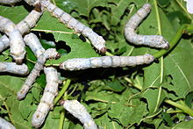 | https://en.wikipedia.org/wiki/Bombyx_mori  https://en.wikipedia.org/wiki/Silk Silk has a smooth, soft texture that is not slippery, unlike many synthetic fibers.
Dogs, Cats, or any animal fur or hair over 2 inches…  including human hair! | 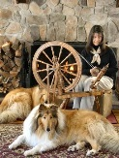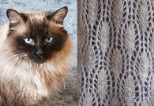 | - http://www.jumaka.com/spinning/petfur.html  - https://en.wikipedia.org/wiki/Chiengora  - http://www.wikihow.com/Make-Dog-Yarn  - https://www.craftsy.com/blog/2014/11/how-to-spin-pet-fur-into-yarn  - https://en.wikipedia.org/wiki/Turkish_Angora  - http://www.nativeearthteachingfarm.org/2008/05/spinning-human-hair.htm
Rabbit -  Angora fiber | 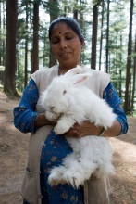 | https://en.wikipedia.org/wiki/Angora_wool Angora is known for its softness, thin fibres, and what knitters refer to as a halo (fluffiness). It is also known for its silky texture. It is much warmer and lighter than wool due to the hollow core of the angora fibre. It also gives them their characteristic floating feel. Angora rabbits produce coats in a variety of colours, from white through tan, gray, and brown to black. Yarns of 100% angora are typically used as accents. They have the most halo and warmth, but can felt very easily through abrasion and humidity and can be excessively warm in a finished garment. The fibre is normally blended with wool to give the yarn elasticity, as Angora fibre is not naturally elastic.
Sheep –  Wool fiber | 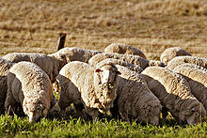 | (Softest or finest is Merino & Rambouillet)  - http://www.amtexyarns.com/different_types_of_wool_sheep.htm for yarn  - https://en.wikipedia.org/wiki/Sheep  - https://en.wikipedia.org/wiki/List_of_sheep_breeds  - https://en.wikipedia.org/wiki/Glossary_of_sheep_husbandry
Goat -  Cashmere & Mohair fiber | 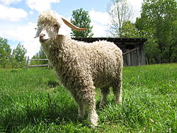 | https://en.wikipedia.org/wiki/Angora_goat Both durable and resilient, mohair is notable for its high luster and sheen,^{[2]} which has helped give it the nickname the "Diamond Fiber",^{[3]} and is often used in fiber blends to add these qualities to a textile. Mohair takes dye exceptionally well. Mohair is warm in winter as it has excellent insulating properties, while remaining cool in summer due to its moisture wicking properties. It is durable, naturally elastic, flame resistant and crease resistant. It is considered to be a luxury fiber, like cashmere, angora and silk, and is usually more expensive than most wool that comes from sheep… mohair does not felt as wool does.
Alpaca | 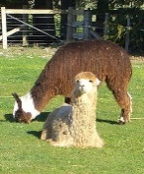 | https://en.wikipedia.org/wiki/Alpaca Alpaca fleece is a lustrous and silky natural fiber. While similar to sheep’s wool, it is warmer, not prickly, and bears no lanolin, which makes it hypoallergenic.^{[17][18]} Without lanolin, it does not repel water. It is also soft and luxurious. In physical structure, alpaca fiber is somewhat akin to hair, being very glossy. The preparing, carding, spinning, weaving and finishing process of alpaca is very similar to the process used for wool. Alpaca fiber is also flame-resistant, and meets the US Consumer Product Safety Commission's standard
Lama | 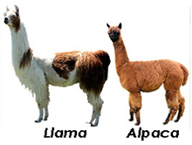 | https://en.wikipedia.org/wiki/Llama Llamas have a fine undercoat, which can be used for handicrafts and garments. The coarser outer guard hair is used for rugs, wall-hangings and lead ropes. The fiber comes in many different colors ranging from white or grey to reddish-brown, brown, dark brown and black. https://www.openherd.com/articles/61/rising-sun-alpacas---alpaca-vs-llama-what-are-the-differences Article: Difference between Llamas and Alpacas:
Musk Oxen –  Quviut fiber | 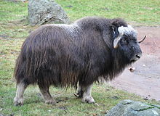 | https://en.wikipedia.org/wiki/Qiviut It is valued for its use as a fiber as, unlike sheep's wool, it does not shrink in water at any temperature. (However, this means that it also is not useful for felting.) It is most commonly used for hats and scarves, and is among the softest wools. It is very expensive; a high quality knitted scarf can cost more than 300 U.S. dollars,^{[4]} but will last over 20 years with good care. The muskox has a two-layered coat, and qiviut refers specifically to the soft underwool beneath the longer outer wool. The muskox sheds this layer of wool each spring. Qiviut is plucked from the coat of the muskox during the molt or gathered from objects the animals have brushed against; unlike sheep, the animals are not sheared.
Note: There are “Angora” Cats, Rabbits, and Goats – all suitable for yarn fiber!

