BASICS:
• After casting on, cut tail end of yarn to about 5 inches, so it is not knitted by mistake.
• Stitches should be snug, but not tight. The loops should be able to slide along the needle.
• When you begin to knit a new row, be sure to knit into the front yarn only and not both front and back.
• After the first 2 knits on your needle, pause, then gently pull on the yarn tail to snug up the knits.
How to hold the needle | Knits (v-shaped) / Purls (wavy bumps) | Always ball your yarn from...  loosely balled yarn, skeins, or hanks.
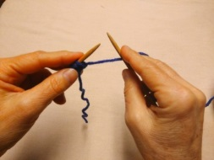 | 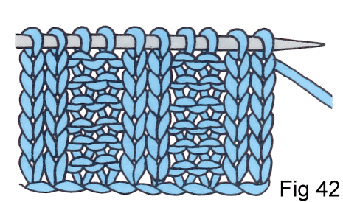 | 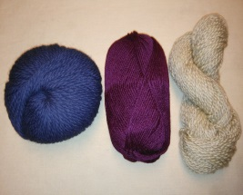
How to hold the yarn: for less tension put yarn between first two fingers only, or hold yarn any way that feels comfortable!
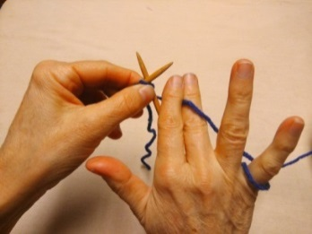 | 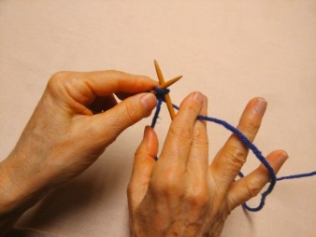 | 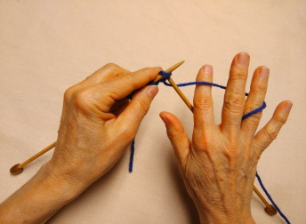 | 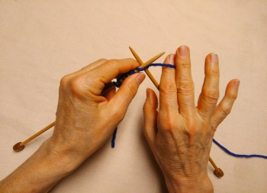
Under Pointer Finger & Wrapped around Pinkie | Under Pointer Finger only | Over Pointer Finger & Wrapped round 3rd Finger | Over Pointer Finger only
YARN BALL
 | read from left to right >
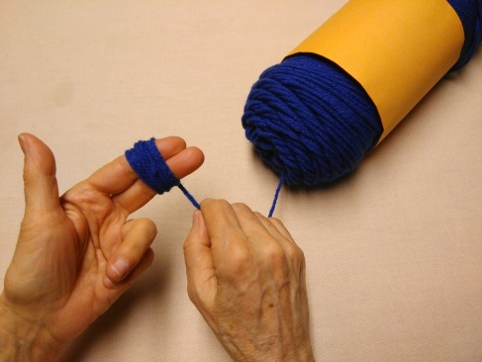 | 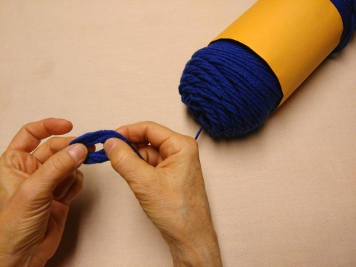 | 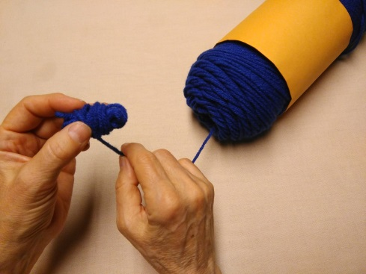
Wrap yarn around 2 fingers 10 times. > | Remove from fingers… > | ….& wrap around middle, making a bow…
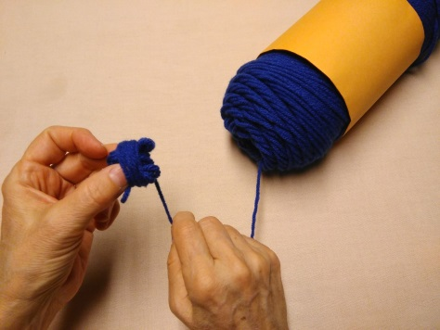 | 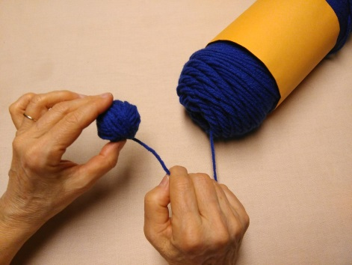 | 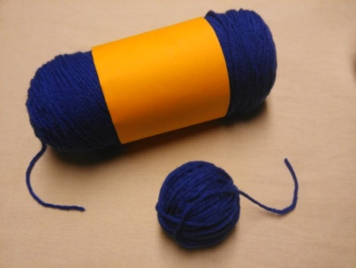
…then fold over on itself… > | … & wrap in all directions… > | …creating a beautiful ball!
Go to http://www.phillyknits.org/Learn2Knit.htm for more print instructions!

