“PHILLY PRIDE”
Yarn Bombers
NEEDED!

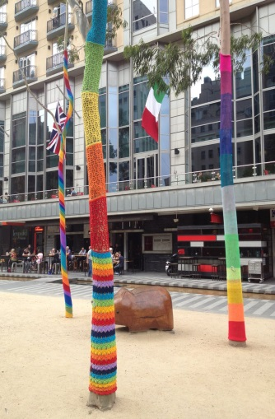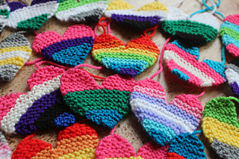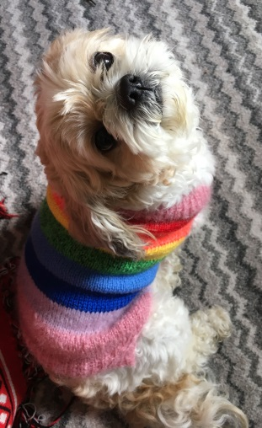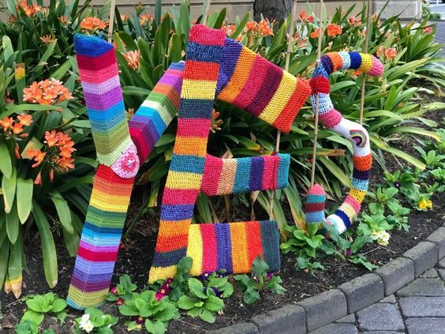

FOR
PHILLY PRIDE MONTH!
Installation, June 5th

Knitters & crocheters needed to make
“Pride” squares, circles, flowers, pompoms, etc!
Sign up @ PhillyKnits.org or MeetUp!

